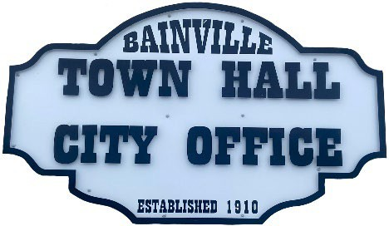Bainville Town Council Meeting Agenda

City Office

211 Clark Ave. East

**Monday September 15, 2025, at 7:00 PM**

* **Call Meeting to Order**
* **Pledge of Allegiance**
* **Roll Call—Establish a quorum.**

Mayor, Toby Romo Councilperson, Will Rathbun

Councilperson, Carol Rasmussen Councilperson, John Gilligan

* **Approval of Agenda***.*
* **Approval of regular meeting minutes dated August 11th, 2025.**
* **Treasurers Report**
  1. Cash Balance Report
  2. Bank Reconciliation Report
  3. YTD Expense vs Budget
  4. YTD Revenue vs Budget
  5. Bank Statements for August 2025.
  6. Utility Billing Receipts for August 2025.
  7. Review of delinquent accounts.
  8. Approve claims & JVs in the amount of $43,232.42.
  9. Approve payroll in the amount of $8,599.67.
* **Public Comments or Formal Complaints on items not on agenda.**
* **Department or Committee Reports:**
  + Public Works-Request for Mini Excavator.
  + Fire Chief Report-
  + Roosevelt County Sheriff’s Department Update- In August 2025, there were 13 Calls for service, 1 arrest, & 3 citations.
  + Committee Reports-
* Cemetery Advisory Committee-
* Bainville Community Development Committee-
* Bainville Community Association-
* **Old Business:**
  1. Nuisance Violations update-The Town sent 10 letters to the property owners & tenants of the properties. Copies of said letters were also sent to Town Attorney Laura Christoffersen, Roosevelt County Attorney, & Roosevelt County Sheriff’s Dept.
  2. Water/sewer/garbage rate study update-Chad Thompson with MAP is currently working on the rate study.

***SEE BACK SIDE***

* **New Business:**
  1. Building Permit-Ernie Bingham, Shop Building.
  2. Growth Policy-It is recommended that the Growth Policy be updated every 5 years. Up to date Growth Policies increase chances of getting grants approved. The town can apply for a CDBG grant for the preparation of a growth policy update.  The CDBG grants are for up to $50,000 with a 25% match required, so the total project would be $62,500.  The grant applications cost $2,500 to prepare, which would be out of pocket for the Town. John Bach from Interstate Engineering will be applying for a grant to update the current Growth Policy.
  3. New flooring for Town Office bid-Glue down vinyl plank flooring throughout the building. Torres Flooring bid $6,980.00
  4. Request for stop signs at the intersection of Flynn Ave & Tubman St.
  5. Halloween 2025 Safety & Activities.
* **Mayor’s Report:**

1. Water loss was at 19% for August 2025.
2. Discussion on FY25-26 Annual Budget.

**Adjourn:**

**\*\*\***Next Regular Meeting will be Monday October 13th, 2025, 7:00pm. City Office***