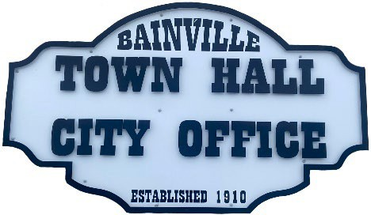
Bainville Town Council Meeting Agenda

City Office

211 Clark Ave. East
Tuesday December 8, 2025, at 7:00 PM

- Call Meeting to Order
- Pledge of Allegiance
- Roll Call—Establish a quorum.
Mayor, Toby Romo Councilperson, Will Rathbun
Councilperson, Carol Rasmussen Councilperson, John Gilligan
- Approval of Agenda.
- Approval of regular meeting minutes dated November 10th, 2025.
- Treasurers Report
  - Cash Balance Report
  - Bank Reconciliation Report
  - YTD Expense vs Budget
  - YTD Revenue vs Budget
  - Bank Statements for November 2025.
  - Utility Billing Receipts for November 2025.
  - Review of delinquent accounts.
  - Approve claims & JVs in the amount of $19,828.64.
  - Approve payroll in the amount of $6,653.59.
- Public Comments or Formal Complaints on items not on agenda.
- Department or Committee Reports:
  - Public Works-Present quotes for seamless gutters at the Bainville lagoon shop.
  - Fire Chief Report-
  - Roosevelt County Sheriff’s Department Update-
  - Committee Reports-
- Cemetery Advisory Committee-
- Bainville Community Development Committee-
- Bainville Community Association-
- Old Business:
  - Growth Policy & grant through Interstate Engineering.
  - Discussion on decreasing the speed limit within the town.
  - Council approval for the Annual Financial Report 2025.
  - Annual Budget 2025-2026 has been submitted to the state for approval.

***SEE BACK SIDE***

- New Business:

  - Discussion on selling the Town of Bainville pivot.
  - Discussion on selling the Town of Bainville John Deere tractor & attachments.
  - Swear in Mayor Toby Romo & Councilperson John Gilligan for their 2026-2029 terms.
- Mayor’s Report:
- Town complaints-
- Water loss was at 9% for November 2025.

Adjourn:

***Next Regular Meeting will be Monday January 12, 2025, 7:00pm. City Office***

